

**Product Dissection for Facebook**

**Company Overview:**

Facebook, launched in 2004 by Mark Zuckerberg and his college roommates, is more than just a social networking platform – it's a global phenomenon that has transformed the way we connect, communicate, and share information. What started as a small project in a Harvard University dorm room has since evolved into the world's largest social media platform, boasting over two billion active users worldwide.

At its core, Facebook is about bringing people together. Whether it's reconnecting with old friends, staying updated on family members' lives, or joining communities that share common interests, Facebook provides a space for individuals to connect and interact in ways that were once unimaginable. With features like personalized profiles, the iconic News Feed, and private messaging through Messenger, Facebook offers a versatile platform for socializing, sharing content, and building communities.

But Facebook's impact extends far beyond individual connections. It has become a driving force in shaping modern society, influencing everything from politics and activism to business and culture. The platform has played a pivotal role in spreading information, sparking conversations, and mobilizing movements on a global scale.

However, Facebook's journey hasn't been without challenges. Alongside its immense reach and influence come concerns about privacy, data security, and the spread of misinformation. As Facebook continues to navigate these complexities, it remains committed to its mission of giving people the power to build community and bring the world closer together.

In this introduction to Facebook, we'll explore the platform's evolution, its key features and functionalities, its impact on society, and the opportunities and challenges it faces as it continues to shape the digital landscape. Join us as we delve into the world of Facebook and uncover the stories behind the world's favorite social network.

**Product Dissection and Real-World Problems Solved by Facebook:**

**Product Dissection of Facebook:**

1. **Core Features**:

**Profile Creation and Customization:** Users can create personalized profiles, adding information about themselves, photos, and other details.

**News Feed:** The central hub of Facebook, where users see updates, photos, videos, and articles from friends, pages, and groups they follow.

**Friends and Followers:** Users can connect with friends and follow other users to stay updated on their activities.

**Groups and Pages**: Facebook hosts millions of groups and pages dedicated to various topics, interests, and communities.

**Messenger:** A messaging platform integrated with Facebook, allowing users to send private messages, make voice and video calls, and engage in group chats.

**Events:** Users can create, discover, and RSVP to events happening in their local area or within their communities.

1. **Facebook Business Tools:**

**Advertising Platform:** Businesses can leverage Facebook's advertising platform to reach their target audiences through targeted ads, sponsored posts, and analytics tools.

**Pages for Businesses:** Businesses can create and manage dedicated pages to engage with customers, share updates, and promote products or services.

**Marketplace:** A platform for buying and selling goods locally, connecting buyers and sellers within communities.

**Real-World Problems Solved by Facebook:**

**Connecting People:** Facebook addresses the need for connectivity and social interaction in an increasingly digital world. It allows individuals to maintain relationships, reconnect with old friends, and forge new connections regardless of geographic barriers.

**Community Building:** Facebook provides a platform for building communities based on shared interests, hobbies, or causes. It facilitates the formation of online communities where individuals can find support, share knowledge, and collaborate on projects.

**Information Sharing and Discovery:** Facebook serves as a hub for sharing and discovering information, news, and content. Users can stay updated on current events, trends, and topics of interest through their News Feed and engagement with groups and pages.

**Business Promotion and Marketing:** For businesses, Facebook offers powerful tools for promotion, marketing, and customer engagement. Through targeted advertising, businesses can reach their ideal customers and drive sales, while also fostering relationships with their audience through organic content and engagement.

**Event Planning and Coordination:** Facebook simplifies event planning and coordination by providing a platform for creating, promoting, and managing events. Users can easily invite friends, share event details, and coordinate logistics, making it easier to bring people together for gatherings and activities.

**Marketplace for Commerce:** With Facebook Marketplace, the platform addresses the need for a convenient and accessible marketplace for buying and selling goods within local communities. It provides individuals and businesses with a platform to trade goods and services, facilitating transactions and fostering economic activity.

In summary, Facebook's suite of features and tools addresses a variety of real-world needs, from social connection and community building to information sharing, business promotion, event coordination, and commerce. By providing a platform for individuals and businesses to connect, communicate, and engage with each other, Facebook plays a significant role in shaping the way people interact and conduct activities in the digital age.

**Case Study: Real-World Problems and Facebook's Innovative Solutions**

**Problem 1: Privacy Concerns and Data Security**

In an era of increasing digital connectivity, users are increasingly concerned about the privacy and security of their personal information shared on social media platforms like Facebook. Instances of data breaches and misuse of user data have eroded trust among users.

**Solution: Enhanced Privacy Controls and Transparency**

Facebook has responded to privacy concerns by introducing enhanced privacy controls and transparency measures. Users now have more granular control over who can see their posts, photos, and personal information. Additionally, Facebook has implemented features such as Privacy Checkup and Data Use Checkup to help users understand and manage their privacy settings effectively. Furthermore, the platform has invested in robust security measures and compliance with data protection regulations like GDPR (General Data Protection Regulation) to safeguard user data.

**Problem 2: Spread of Misinformation and Fake News**

The proliferation of misinformation and fake news on social media platforms like Facebook has become a significant concern, impacting public discourse, political elections, and social cohesion. False information spreads rapidly across the platform, leading to confusion and polarization among users.

**Solution: Fact-Checking Partnerships and Content Moderation**

To combat the spread of misinformation, Facebook has implemented various measures, including partnerships with third-party fact-checkers to review and flag potentially false content. Articles flagged as false are down-ranked in the News Feed and accompanied by fact-checker notifications. Additionally, Facebook has expanded its team of content moderators to identify and remove harmful content, such as hate speech, violence, and graphic imagery, from the platform. The platform also promotes media literacy and critical thinking through educational initiatives to help users discern credible information from misinformation.

**Problem 3: Online Harassment and Bullying**

Social media platforms like Facebook have become breeding grounds for online harassment and bullying, negatively impacting the mental health and well-being of users, particularly adolescents and young adults.

**Solution: Anti-Bullying Tools and Reporting Mechanisms**

Facebook has implemented anti-bullying tools and reporting mechanisms to address online harassment and bullying. Users can block or report abusive content, accounts, or comments, empowering them to take control of their online experience. Additionally, Facebook has introduced features such as comment filters, keyword filters, and the ability to restrict interactions with certain users to mitigate the impact of harassment. Furthermore, the platform collaborates with experts and organizations to develop resources and support services for victims of online abuse.

**Problem 4: Advertiser Transparency and Authenticity**

Concerns about the authenticity and transparency of advertising on Facebook have arisen, with instances of misleading or deceptive ads undermining user trust and credibility.

**Solution: Advertiser Verification and Ad Transparency Tools**

Facebook has implemented measures to enhance advertiser transparency and authenticity. Advertisers are required to undergo a verification process to confirm their identity and legitimacy before running ads on the platform. Additionally, Facebook provides users with ad transparency tools, such as the Ad Library, where they can view information about ads, including the advertiser's identity, budget, and targeting criteria. Moreover, Facebook has introduced policies to prohibit deceptive advertising practices and ensure that ads meet community standards and guidelines.

**Problem 5: Digital Well-Being and Time Management**

Excessive use of social media platforms like Facebook has been linked to issues related to digital well-being, such as addiction, distraction, and decreased productivity. Users struggle to manage their time and attention effectively in an environment designed to maximize engagement.

**Solution: Time Management Tools and Well-Being Initiatives**

Facebook has introduced time management tools and well-being initiatives to help users maintain a healthy balance between their online and offline lives. Features such as Activity Dashboard, Daily Reminder, and Quiet Mode allow users to track their time spent on the platform, set usage limits, and minimize distractions. Furthermore, Facebook collaborates with mental health experts and organizations to promote digital well-being and provide resources for users to manage screen time effectively. The platform also encourages users to engage in meaningful interactions and prioritize real-life connections over excessive social media usage.

### Top Features of Facebook:

Facebook offers a plethora of features designed to enhance user experience and facilitate communication, connection, and engagement. Here are some of its top features:

1. **Profile Creation and Customization:** Users can create personalized profiles, adding information about themselves, photos, interests, and more. Profiles can be customized with cover photos, profile pictures, and featured posts.
2. **News Feed:** The News Feed is the central hub of Facebook, where users see updates, photos, videos, and articles from friends, pages, and groups they follow. It provides a personalized stream of content tailored to each user's interests and interactions.
3. **Friends and Followers:** Facebook allows users to connect with friends and follow other users to stay updated on their activities. Users can send friend requests, accept friend requests, unfollow or block users, and manage their friend lists.
4. **Groups and Pages:** Facebook hosts millions of groups and pages dedicated to various topics, interests, and communities. Groups provide a space for users to connect, share content, and engage in discussions with like-minded individuals, while pages allow businesses, organizations, and public figures to interact with their audience and share updates.
5. **Messenger:** Facebook's messaging platform enables users to send private messages, make voice and video calls, and engage in group chats with friends and contacts. Messenger is integrated with Facebook, allowing seamless communication between users across different platforms.
6. **Events:** Facebook Events allow users to create, discover, and RSVP to events happening in their local area or within their communities. Users can create event pages, invite friends, share event details, and coordinate logistics, making it easy to organize and attend gatherings and activities.
7. **Photo and Video Sharing:**Facebook provides robust features for sharing photos and videos with friends and followers. Users can upload photos and videos directly to their profiles, create photo albums, share stories, and broadcast live videos.
8. **Timeline and Tagging:**The Facebook Timeline serves as a digital timeline of users' lives, displaying their posts, photos, and activities in chronological order. Users can tag friends in posts and photos, mention them in comments, and share memories and milestones with their social network.
9. **Privacy Controls:** Facebook offers extensive privacy controls, allowing users to customize who can see their posts, photos, and personal information. Users can adjust their privacy settings, manage their audience, block users, and report abusive content to ensure a safe and secure online experience.
10. **Marketplace:**Facebook Marketplace provides a platform for buying and selling goods locally, connecting buyers and sellers within communities. Users can browse listings, search for items, negotiate prices, and complete transactions directly through the platform.

These are just a few of the many features that make Facebook a versatile and comprehensive social networking platform, catering to the diverse needs and interests of its global user base.

**Schema Description:**

The schema for Facebook encompasses various entities that capture different aspects of the platform's functionality. These entities include Users, Posts, Comments, Likes, Friendships, Groups, Pages, and Messages. Each entity possesses specific attributes defining its properties and relationships with other entities.

**User Entity:**

Users serve as the foundation of Facebook, with the user entity containing pertinent information about each user:

* **UserID (Primary Key):** A unique identifier for each user.
* **Username:** The chosen username for the user's account.
* **Email:** The email address associated with the user's account.
* **Password:** The hashed password used for account authentication.
* **Full_Name:** The user's full name as displayed on their profile.
* **Bio:** A brief description allowing users to express themselves.
* **Birthdate:** The user's date of birth.
* **Gender:** The user's gender identity.
* **Location:** The user's current or preferred location.
* **Relationship_Status:** The user's current relationship status.
* **Join_Date:** The date when the user joined Facebook.

**Post Entity:**

Posts encapsulate the content shared on the platform:

* **PostID (Primary Key):** A unique identifier for each post.
* **UserID (Foreign Key referencing User Entity):** The user who created the post.
* **Content:** The textual or multimedia content of the post.
* **Privacy_Setting:** The privacy setting chosen by the user for the post (Public/Friends/Custom).
* **Post_Date:** The date and time when the post was created.

**Comment Entity:**

Comments enable users to engage in discussions around posts:

* **CommentID (Primary Key):** A unique identifier for each comment.
* **PostID (Foreign Key referencing Post Entity):** The post being commented on.
* **UserID (Foreign Key referencing User Entity):** The user who posted the comment.
* **Content:** The textual content of the comment.
* **Comment_Date:** The date and time when the comment was posted.

**Like Entity:**

Likes represent user appreciation for posts:

* **LikeID (Primary Key):** A unique identifier for each like.
* **PostID (Foreign Key referencing Post Entity):** The post being liked.
* **UserID (Foreign Key referencing User Entity**): The user who liked the post.
* **Like_Date:** The date and time when the like was registered.

**Friendship Entity:**

Friendships establish connections between users:

* **FriendshipID (Primary Key):** A unique identifier for each friendship relationship.
* **UserID1 (Foreign Key referencing User Entity):** The first user in the friendship.
* **UserID2 (Foreign Key referencing User Entity):** The second user in the friendship.
* **Status:** The status of the friendship (Accepted/Pending/Declined/Blocked).
* **Friendship_Date:** The date when the friendship relationship was initiated.

**Group Entity:**

Groups provide a space for users to connect and engage based on shared interests:

* **GroupID (Primary Key):** A unique identifier for each group.
* **Group_Name:** The name of the group.
* **Description:** A brief description of the group's purpose or topic.
* **AdminID (Foreign Key referencing User Entity):** The user who created the group.
* **Creation_Date:** The date when the group was created.

**Page Entity:**

Pages allow businesses, organizations, and public figures to interact with their audience:

* **PageID (Primary Key):** A unique identifier for each page.
* **Page_Name:** The name of the page.
* **Description:** A brief description of the page's purpose or entity.
* **AdminID (Foreign Key referencing User Entity):** The user who manages the page.
* **Creation_Date:** The date when the page was created.

**Message Entity:**

Messages facilitate private communication between users:

* **MessageID (Primary Key**): A unique identifier for each message.
* **SenderID (Foreign Key referencing User Entity**): The user who sent the message.
* **ReceiverID (Foreign Key referencing User Entity):** The user who received the message.
* **Content:** The textual content of the message.
* **Message_Date:** The date and time when the message was sent.

This schema captures the fundamental structure of Facebook's database, including users, posts, comments, likes, friendships, groups, pages, and messages, along with their respective attributes and relationships.

**Relationships**

The relationships between the entities in the Facebook schema:

* **One-to-Many Relationship: User to Posts:** Each user can create multiple posts, but each post is created by only one user.
* **One-to-Many Relationship: User to Comments:** Each user can post multiple comments, but each comment is posted by only one user.
* **One-to-Many Relationship: User to Likes:** Each user can like multiple posts, but each like is associated with only one user.
* **Many-to-Many Relationship: User to Friendships:** Each user can have multiple friends, and each friend can have multiple users as friends.
* **One-to-Many Relationship: User to Groups:** Each user can create/manage multiple groups, but each group is managed by only one user.
* **One-to-Many Relationship: User to Pages:** Each user can create/manage multiple pages, but each page is managed by only one user.
* **One-to-Many Relationship: User to Messages (Sender/Receiver):** Each user can send/receive multiple messages, but each message has only one sender and one receiver.
* **One-to-Many Relationship: Post to Comments:** Each post can have multiple comments, but each comment is associated with only one post.
* **One-to-Many Relationship: Post to Likes:** Each post can have multiple likes, but each like is associated with only one post.
* **Many-to-Many Relationship: Post to Hashtags (via PostHashtag Entity):** Each post can have multiple hashtags, and each hashtag can be associated with multiple posts.

These relationships define how different entities in the Facebook schema are related to each other and how data flows between them. They help maintain data integrity and consistency within the database.

**ER Diagram:**

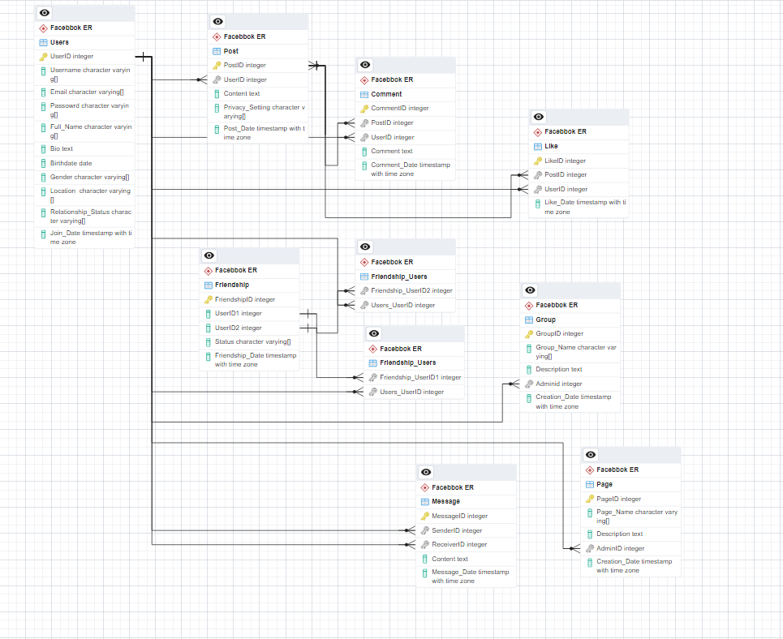

**Conclusion**

In this case study, we explored the schema and Entity-Relationship diagram of Facebook, a pioneering force in the realm of social media. Facebook's database architecture, comprising entities such as users, posts, comments, likes, friendships, groups, pages, and messages, serves as the backbone of its multifaceted platform. Through a deep dive into these entities and their attributes, we gained a comprehensive understanding of how Facebook captures, organizes, and facilitates user interactions and content sharing.

Facebook's innovative solutions to real-world problems, including privacy concerns, misinformation, and online harassment, underscore the platform's commitment to creating a safe, inclusive, and meaningful online environment. By implementing enhanced privacy controls, partnering with fact-checkers, and deploying anti-bullying tools, Facebook continuously strives to address societal challenges and promote positive engagement among its global user base.

Overall, the schema description of Facebook provides valuable insights into the platform's complexity, versatility, and impact on modern communication. Through its data-driven approach and dedication to innovation, Facebook continues to shape the landscape of social media, connecting billions of people worldwide and fostering communities that thrive on shared interests, experiences, and values.